PRODUCT INFORMATION DEEP 1-3

 |  |  |  |  | 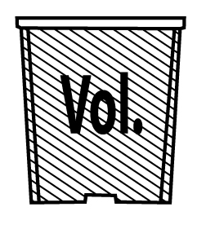
 | 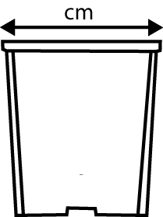 |  | 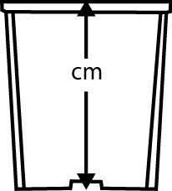 |  |  |  | 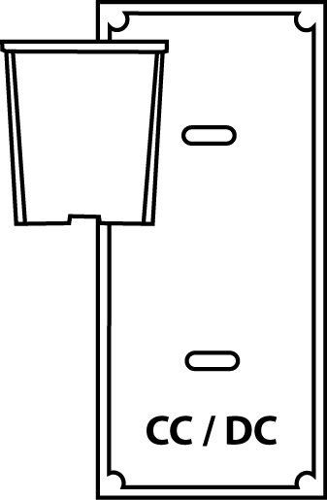 |  | 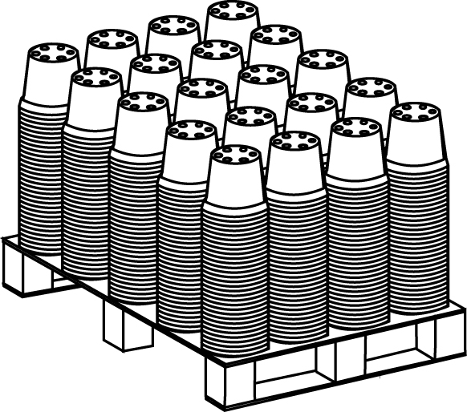  pallet size  120x100x120 | palllet size  120x100x240
C 2.0 R | 13 |  | 19 |  | 2.0 |  | 44 |  | 4.410
C 2.5 R SLOT 40MM | 13.5 |  | 20.5 |  | 2.5 |  | 36 |  | 2.520
C 3.0 R | 15 |  | 21 |  | 3.0 |  | 36 |  | 2.688
C 3.0 R SLOT 40MM | 15 |  | 22.5 |  | 3.0 |  | 36 |  | 2.400
C 3.0 R | 16.5 |  | 19 |  | 3.0 |  | 30 |  |  | 7.140
C 3.5 SQ SLOT 25MM | 14.5x14.5 |  | 20.5 |  | 3.5 |  | 36 |  |  | 5.264
C 4.0 RA | 19 |  | 21 |  | 4.0 |  | 21 |  | 1.960
C 4.0 R SLOT 28 MM / 54MM | 18.5 |  | 21.3 |  | 4.0 |  | 21 |  |  | 5.040
C 6.7 | 23 |  | 22 |  | 6.7 |  | 17 |  |  | 2.520
36SR DEEP SLOT 26MM | 14 x 14 |  | 19,7 |  | 2.7 |  | 36 |  |  | 4.368
24SR DEEP SLOT 26MM | 15,8 x 15,8 |  | 21 |  | 4.0 |  | 24 |  |  | 3.402
21SR DEEP SLOT 40MM | 18 x 18 |  | 24 |  | 5.5 |  | 21 |  | 1.015 | 2.520
MCA 15 SLOT 29 MM |  | 15 x 15 |  | 20 |  | 3.5 |  | 24 | 4.080
MCA 18 SLOT 36 MM |  | 18 x 18 |  | 23 |  | 5.5 |  | 21 | 2.040
MCA 20 |  | 20 x 20 |  | 25 |  | 7.0 |  | 12 | 1.740
MCA 23 SLOT 36 MM |  | 23 x 23 |  | 27 |  | 11.0 |  | 10 | 1.000
CARRYING HANDLE 60 CM LENGTH FOR 26MM SLOT |  |  |  |  |  |  | 1.000 pcs/box |  | 18boxes/pall
CARRYING HANDLE 60 CM LENGTH FOR 40MM SLOT |  |  |  |  |  |  | 1.000 pcs/box |  | 18boxes/pall
LABEL HOLDER UNIVERSAL 28CM  (FOR POTS WITH A RIM) |  |  |  |  |  |  | 1.000 pcs/box |  | 20boxes/pall
LABEL HOLDER DECO 28CM  (FOR CAMPANA-AND PATIO POTS) |  |  |  |  |  |  | 1.000 pcs/box |  | 20boxes/pall
CANE CAP |  |  |  |  |  |  | 1.500  pcs/box

